Description

Differential expression of genes associated with ingestion of histamine and serotonin by Anopheles stephensi

Malaria remains a global burden with very high associated morbidity and mortality. Upon severe falciparum infection, host’s blood histamine levels increase whereas serotonin levels decrease. These biogenic amines (histamine and serotonin) are important neuromodulators with receptors expressed in the midgut and head of the mosquito. Previous studies have shown enhanced Anopheles stephensi susceptibility to parasite infection and feeding behaviour following ingestion of the biogenic amines. However, very little is known on the physiology of the mosquito (that is, what happens in the body of the mosquito and the genes that might be involved). In this project, RNA was extracted from midgut, carcass, and whole-body tissues at two time points (6 and 24 hours) following dissection of mosquitoes provisioned with 1nM histamine and 1.5 μM serotonin (healthy associated host blood concentration) and 10nM histamine and 0.15 μM serotonin (malaria associated host blood concentrations). The samples were prepared for RNA sequencing and raw reads obtained for downstream analyses. This would be important in providing information in the gaps in literature via assessing the differential expression of genes associated with ingestion of the biogenic amines and possibly provide some mechanisms associated with biogenic amine signalling in the mosquito. Knowledge from this biology is essential in providing alternative targets for vector control and/or reducing malaria parasite transmission especially in endemic areas.

Project log:
Data acquisition
Sequence data was acquired using :
wget -r -c -nH --cut-dirs=1 --no-parent --reject "index.html*" https://gc3fstorage.uoregon.edu/HFL7CDRX3/7161/

Data available were four replicates each of Mosquito tissues (Midgut, carcass, whole body) provisioned with 1nM histamine and 1.5 μM serotonin (healthy associated host blood concentration) and 10nM histamine and 0.15 μM serotonin (malaria associated host blood concentrations) at 6 and 24 hour time points post blood meal.

Due the size of the size I chose to use a subset of the data to reduce the number of samples from 64 to 12.
Therefore, I chose the whole-body samples only at 0.15uM Serotonin and 10nM concentrations which are the malaria associated concentrations.

Quality control and trimming
Quality control was carried out on raw data using:
Fastqc *.gz

After this, the sequences were then trimmed with Trimmomatic using:
#!/bin/bash
cd $SLURM_SUBMIT_DIR
echo "running on"
hostname
source /usr/modules/init/bash

module load trimmomatic/0.39

# Define input directory
input_dir=$(pwd)

# Define output directory
output_dir="${input_dir}/trimmed"

# Create output directory if it doesn't exist
mkdir -p "$output_dir"

# Define adapter file
adapter_file="adapters.fa"

# Loop through each .gz file in the input directory
for input_file in "$input_dir"/*.gz; do
# Extract the file name without extension
filename=$(basename "$input_file" .fastq.gz)

# Define output file name
output_file="${output_dir}/${filename}_trimmed.fastq.gz"

# Run Trimmomatic
trimmomatic SE -phred33 "$input_file" "$output_file" \
ILLUMINACLIP:"$adapter_file":2:30:10 LEADING:3 TRAILING:3 SLIDINGWINDOW:4:15 MINLEN:36
done
echo “finished”

Quality control was carried out on trimmed data to confirm adapter contamination had been resolved using:
Fastqc *.gz

Building reference genome

Reference genome was downloaded from:
https://www.ncbi.nlm.nih.gov/assembly/GCF_013141755.1

The command was curled for copying and downloaded using:
Wget “https://api.ncbi.nlm.nih.gov/datasets/v2alpha/genome/accession/GCF_013141755.1/download?include_annotation_type=GENOME_FASTA&include_annotation_type=GENOME_GFF&include_annotation_type=RNA_FASTA&include_annotation_type=CDS_FASTA&include_annotation_type=PROT_FASTA&include_annotation_type=SEQUENCE_REPORT&hydrated=FULLY_HYDRATED”

The reference was then built using:

hisat2-build -p 16 GCF_013141755.1_UCI_ANSTEP_V1.0_genomic.fna An_stephensi_ref

Following this, read mapping was carried out using:

#!/bin/bash
cd $SLURM_SUBMIT_DIR
echo "running on"
hostname
source /usr/modules/init/bash

module load hisat2/2.2.1

# Define variables
INDEX_PATH="/mnt/ceph/bent4061/RNA_seq/7161/for_project/trimmed/An_stephensi_ref"
OUT_DIR="mapping_results"

# Create output directory if it doesn't exist
mkdir -p $OUT_DIR

# Loop over each single-end FASTQ file
for FASTQ_FILE in REP*.fastq.gz; do
# Extract sample name from the filename
SAMPLE=$(basename $FASTQ_FILE .fastq.gz)

# Run HISAT2 alignment for single-end reads
hisat2 --dta -x $INDEX_PATH -U $FASTQ_FILE -S $OUT_DIR/$SAMPLE.sam --summary-file $OUT_DIR/$SAMPLE.summary.txt
done
echo "finished"
Transcript quantification:
Following read mapping, sam files were converted to bam files using:

#!/bin/bash
cd $SLURM_SUBMIT_DIR
echo "running on"
hostname
source /usr/modules/init/bash

module load samtools

# Define variables
SAM_DIR="/mnt/ceph/bent4061/RNA_seq/7161/for_project/trimmed/mapping_results/sam_files"
BAM_DIR="bam_files"

# Create output directory for BAM files if it doesn't exist
mkdir -p $BAM_DIR

# Convert SAM files to BAM, sort, and index
for SAM_FILE in $SAM_DIR/*.sam; do
# Extract sample name from the filename
SAMPLE=$(basename $SAM_FILE .sam)

# Convert SAM to BAM
samtools view -bS $SAM_FILE > $BAM_DIR/$SAMPLE.bam

# Sort BAM file
samtools sort $BAM_DIR/$SAMPLE.bam -o $BAM_DIR/$SAMPLE.sorted.bam

# Index sorted BAM file
samtools index $BAM_DIR/$SAMPLE.sorted.bam
done
echo "finished"

Running stringtie
The following scripts were used:

01:
#!/bin/bash
cd $SLURM_SUBMIT_DIR
echo "running on"
hostname
source /usr/modules/init/bash

module load stringtie

# Define input and output directories
BAM_DIR="/mnt/ceph/bent4061/RNA_seq/7161/for_project/trimmed/mapping_results/sam_files/bam_files/sorted_bam"
OUTPUT_DIR="01_stringtie_files"

# Create output directory if it doesn't exist
mkdir -p $OUTPUT_DIR

# Loop over each BAM file
for BAM_FILE in $BAM_DIR/*.bam; do
# Extract sample name from the filename
SAMPLE=$(basename $BAM_FILE .sorted.bam)

# Run StringTie for transcript assembly
stringtie -G /mnt/ceph/bent4061/RNA_seq/7161/for_project/trimmed/An_stephensi_genome/genomic.gff -o $OUTPUT_DIR/$SAMPLE.gtf $BAM_FILE
done
echo "finished"

02:
#!/bin/bash
cd $SLURM_SUBMIT_DIR
echo "running on"
hostname
source /usr/modules/init/bash

module load stringtie

# Define input and output directories
GTF_DIR="/mnt/ceph/bent4061/RNA_seq/7161/for_project/trimmed/mapping_results/sam_files/bam_files/sorted_bam/01_stringtie_files"
OUTPUT_DIR="02_stringtie_files"

# Create output directory if it doesn't exist
mkdir -p $OUTPUT_DIR

# Run StringTie to merge all GTF files
stringtie --merge -G /mnt/ceph/bent4061/RNA_seq/7161/for_project/trimmed/An_stephensi_genome/genomic.gff $GTF_DIR/*.gtf -o $OUTPUT_DIR/merged.gtf

echo "finished"

03:
#!/bin/bash
cd $SLURM_SUBMIT_DIR
echo "running on"
hostname
source /usr/modules/init/bash

module load stringtie

# Define input and output directories
BAM_DIR="/mnt/ceph/bent4061/RNA_seq/7161/for_project/trimmed/mapping_results/sam_files/bam_files/sorted_bam"
OUTPUT_DIR="final_stringtie_output"

# Create output directory if it doesn't exist
mkdir -p $OUTPUT_DIR

# Run StringTie using the merged GTF file
for BAM_FILE in $BAM_DIR/*.bam; do
# Extract sample name from the filename
SAMPLE=$(basename $BAM_FILE .bam)

# Run StringTie
stringtie -B -e -G /mnt/ceph/bent4061/RNA_seq/7161/for_project/trimmed/mapping_results/sam_files/bam_files/sorted_bam/01_stringtie_files/02_stringtie_files/merged.gtf -A $OUTPU$
done

echo "finished"

The abundance files from the final stringtie output were converted to csv and transferred via FileZilla to the computer for further computation and differential gene expression analysis.

Differential gene expression analysis
All gene names were extracted into column 1 and the respective counts for all samples (four replicates of 0.15uM Serotonin, 10nM Histamine, Control each) tabulated into Microsoft Excel (Version 16.84 (24041420)).

The averages for all replicates were taken and the fold changes calculated by dividing average of treatments by the respective average of control. The fold changes were then converted to log to the base 2. The P value (<0.05) was then calculated using a paired one-tailed T-test.
Following this, the calculated P-value was adjusted for false discovery rate (FDR) correction and control using the Benjamini-Hochberg procedure.

A volcano plot was then made plotting the values of Adjusted P-value (from FDR correction) against log to the base 2 (Log2FC) in GraphPad prism (Version 10.2.0 (335)).

Results
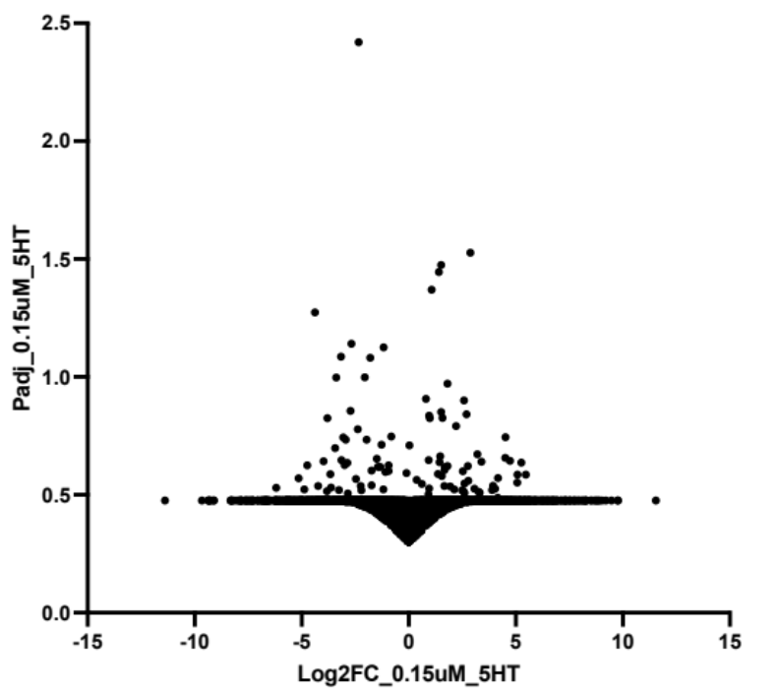

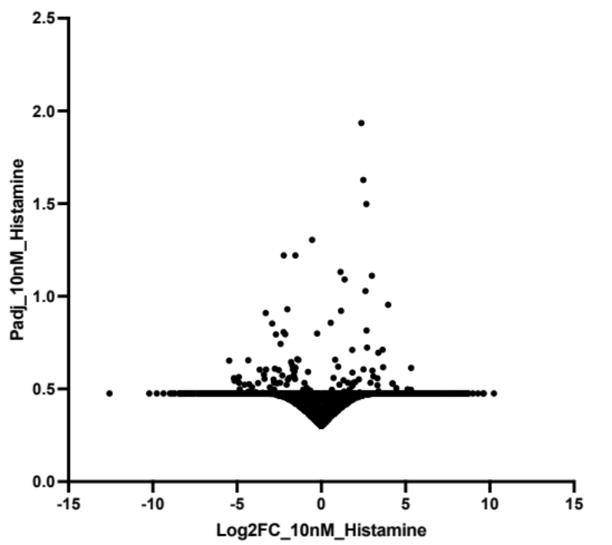

Challenges overcome

The initial idea was to write a script to carry out the differential gene expression analysis in python. However, most of the packages that people have used in many publications (such as DESeq2 and edgeR) were in R. And to do this meant I had to create an environment in python to be able to run R packages. Therefore, I decided to use R directly. The primary challenge I had here was modifying my data such that R would be able to recognize the various columns to get my desired output- the header was not recognized when I read my data into R and had challenges trying to convert my data into a data matrix which would make all of it recognizable.
I therefore resorted to reading resources that explained some basic concepts of differential gene expression analysis thus my being able to analyze the data to some extent in Microsoft excel.

In the future however, I’m hoping to practice more to most importantly learn to deal with the gaps and discrepancies in the data for ease of use in Python R and other statistical programs.

